Why Use/Necessary: Prediction, Data Availability

Data analytics has become an indispensable tool in the modern world, driven by the need for informed decision-making, accurate predictions, and effective strategies across various sectors. The significance of data analytics lies in its ability to transform vast and complex datasets into actionable insights, providing a competitive edge and operational efficiency.



# **Importance of Data Analytics**

**At the heart of modern strategic planning lies data analytics, enabling organizations to navigate the vast ocean of available data to unearth actionable insights. By systematically analyzing data, businesses can determine patterns, trends, and anomalies, transforming raw data into strategic intelligence. This transition from intuition-based to data-driven decision-making enhances accuracy and efficiency, mitigating risks, and capitalizing on opportunities with precision (Provost & Fawcett, 2013).**



# **Prediction**

The ability to forecast future trends and behaviours is a pivotal application of data analytics. In sectors like finance, healthcare, and retail, predictive analytics is a strategic imperative, informing decisions from market investments to patient care protocols and inventory management (Bose, 2009). Predictive analytics also extends to risk assessment, enabling organizations to identify potential pitfalls and strategize pre-emptively, safeguarding their interests.

Furthermore, predictive analytics underpins the shift toward customer-centric business models, enabling personalization and enhancing customer engagement by anticipating needs and preferences (Peppers & Rogers, 1997).

# **Data Availability: The Fuel for Analytics**

The proliferation of big data in the digital era has revolutionized the landscape of data analytics. The abundance of data, coupled with advanced analytical tools, has democratized the ability to glean insights, making analytics accessible to a broader range of businesses and sectors.

* **Technological Advancements**: The surge in data generation is matched by technological advancements that facilitate the efficient processing, storage, and analysis of vast datasets. This synergy between data availability and technology empowers organizations to harness the power of analytics, irrespective of their size or industry (Kshetri, 2014).
* **Real-Time Data Processing**: The value of data is often time-sensitive, particularly in fast-paced environments where decisions must be made swiftly and accurately. Real-time data processing allows organizations to act on insights almost instantaneously, adjusting to market dynamics, responding to emerging trends, and addressing challenges as they arise, providing a competitive edge in a rapidly evolving landscape (Bifet & Kirkby, 2009).
* **Strategic Decision-Making**: With the wealth of data at their disposal, organizations can make more informed, strategic decisions. Data availability enables a comprehensive view of business operations, market conditions, and customer insights, leading to better-aligned strategies and outcomes.
* **Innovation and Growth**: The accessibility of diverse data sets also fuels innovation, driving the development of new products, services, and business models. By leveraging data from various sources, companies can uncover unique insights, identify new opportunities, and foster growth in an increasingly data-driven world.

The digital age's big data explosion has made analytics indispensable for extracting actionable insights and competitive intelligence. The democratization of data, propelled by technological advancements, allows entities of all sizes to harness the power of analytics. Real-time data processing, critical in an era where promptness is as crucial as accuracy, provides organizations with a definitive edge, enabling rapid responses to market changes or emergent challenges.

# **Applications Across Diverse Fields**

* **Healthcare**: Data analytics aids in disease predictive modelling, patient outcome analysis, and treatment optimization. During the COVID-19 pandemic, analytics played a vital role in tracking infection rates and guiding public health policies.
* **Finance**: Financial institutions use analytics for risk assessment, fraud detection, and customer segmentation, enhancing security and operational efficiency.
* **Marketing**: Analytics helps understand customer preferences and tailor marketing strategies, boosting engagement and ROI.
* **Retail**: Retailers employ analytics for inventory management and demand forecasting, improving customer satisfaction and sales.

# **Real-World Example: Amazon's Use of Data Analytics**

## Amazon's recommendations

Amazon's recommendation engine exemplifies data analytics in action. By analyzing customer behaviour and preferences, Amazon personalizes product suggestions, boosting user experience and sales, and illustrating predictive analytics' tangible benefits in enhancing customer satisfaction and revenue growth.

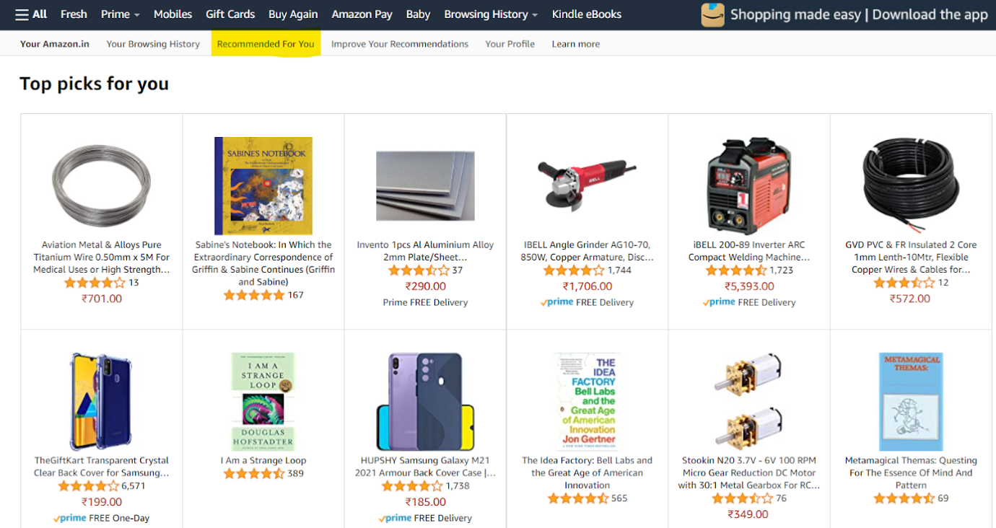

## Walmart's Inventory Management

Walmart's analytics-driven inventory management optimizes stock levels based on predictive data analysis, enhancing efficiency and customer satisfaction.

## Uber's Dynamic Pricing

Uber employs analytics for dynamic pricing, adjusting real-time prices to balance driver supply and user demand, demonstrating analytics' strategic application in service industries.

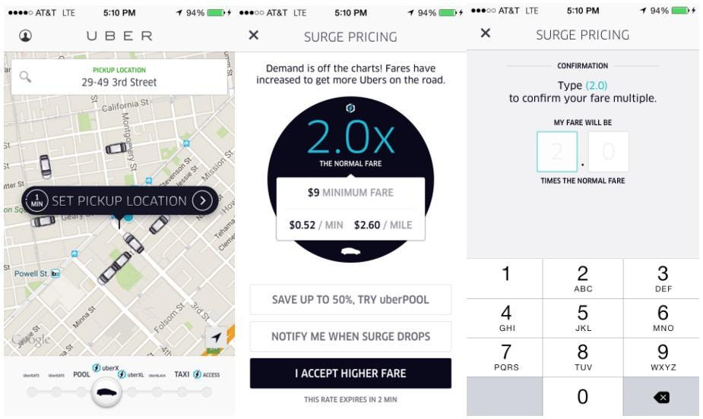

## Zara's Fast Fashion Strategy

Zara uses analytics to adapt rapidly to market demands, showcasing its pivotal role in the retail sector's competitive strategy.

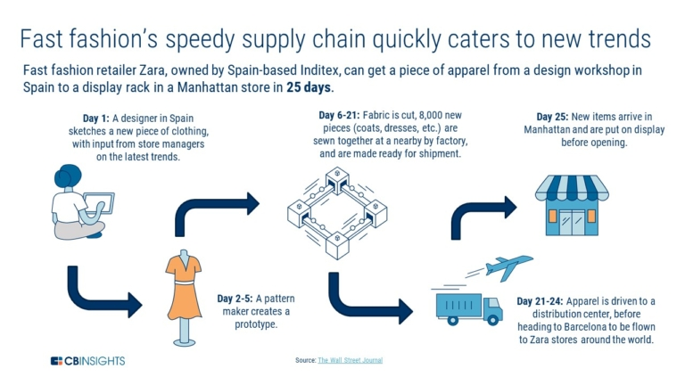

## Netflix's Personalized Recommendations

Netflix's recommendation engine, powered by analytics, personalizes viewer content, enhancing satisfaction and retention, and highlighting analytics' impact on entertainment.

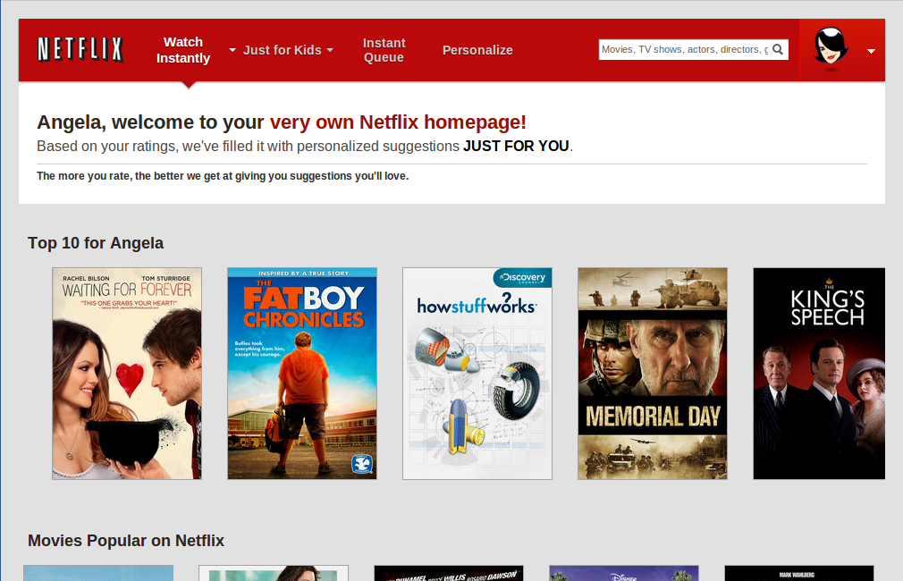

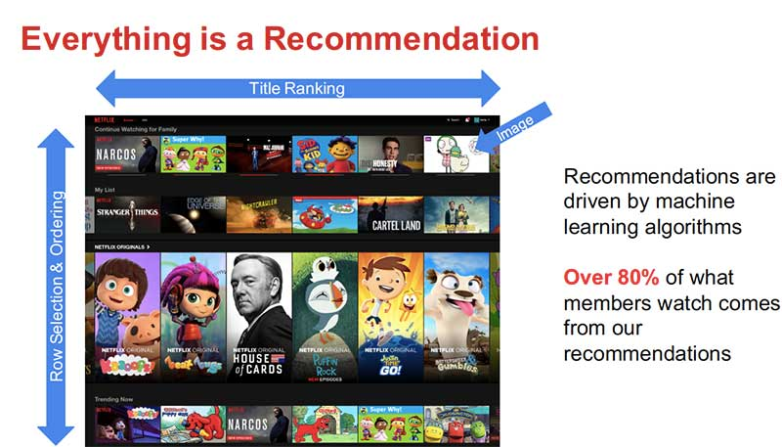

# **Conclusion**

Data analytics' necessity and utility are clear across sectors, offering predictive insights, informed decision-making, and effective data utilization. Real-world examples from Amazon, Walmart, Uber, Zara, and Netflix underscore data analytics' relevance and impact, providing valuable insights for organizations leveraging this tool.

# **References**

* Bose, R. (2009). Advanced analytics: opportunities and challenges. Industrial Management & Data Systems, 109(2), 155-172.
* Bifet, A., & Kirkby, R. (2009). Data stream mining: A practical approach. The University of Waikato.
* Kshetri, N. (2014). Big data’s impact on privacy, security and consumer welfare. Telecommunications Policy, 38(11), 1134-1145.
* Peppers, D., & Rogers, M. (1997). Enterprise one to one: Tools for competing in the interactive age. Currency Doubleday.
* Provost, F., & Fawcett, T. (2013). Data Science for Business: What you need to know about data mining and data-analytic thinking. O'Reilly Media, Inc.